**Assignment 02**

**Building a Sales Management Application with Windows Forms**

# Introduction

Imagine you're an employee of a product retailer named **FStore**. Your manager has asked you to develop a Windows Forms application for member management, product management, and order management. The application has a default account whose email is “**admin@fstore.com**” and password is “**admin@@**” that stored in the **appsettings.json**.

The application has to support adding, viewing, modifying, and removing products—a standardized usage action verbs better known as Create, Read, Update, Delete (CRUD) and Search. This assignment explores creating an application using Windows Forms with .NET Core, C#, and ADO.NET / Entity Framework. An MS SQL Server database will be created to persist the data and it will be used for reading and managing data.

# Assignment Objectives

In this assignment, you will:

* Use the Visual Studio.NET to create Windows Forms and Class Library (.dll) project.
* Develop MDI (Multiple Document Interface) application using WinForms.
* Perform CRUD actions using ADO.NET and Entity Framework Core
* Use LINQ to query and sort data
* Apply passing data in WinForms application
* Apply 3-layers architecture to develop an application
* Apply MPV (Model-Presenter-View) pattern in WinForms application
* Apply Repository pattern and Singleton pattern in a project
* Add CRUD and searching actions to WinForms application.
* Apply to validate data type for all fields
* Run the project and test the WinForms actions.

# Database Design

# 

# Main Functions

* Member management, Product management, and Order management: Read, Create, Update and Delete actions. Creating and Updating actions must be performed by popup dialog
* Search Product by ID , ProductName (keywork of ProductName), UnitPrice, and UnitInStock
* Create a report statistics sales by the period from StartDate to EndDate, and sort sales in descending order
* Member authentication by Email and Password. If the user is “**Admin**” then allows to perform all actions, otherwise, the normal user is allowed to view/update the profile and view their orders history.

# Guidelines

# Activity 01: Build a solution [01 mark]

Create a Blank Solution named **Ass02Solution** that includes Class Library Project: **DataAccess, BusinessObject,** and a Windows Forms project named **SalesWinApp**

**Step 01**. Open the Visual Studio .NET application and create a Blank solution named **Asm02Solution**

**Step 02.** Create a Class Library project named **DataAccess**

From the File menu | Add | New Project, on the Add New Project dialog, select “Class Library” and performs steps as follows:

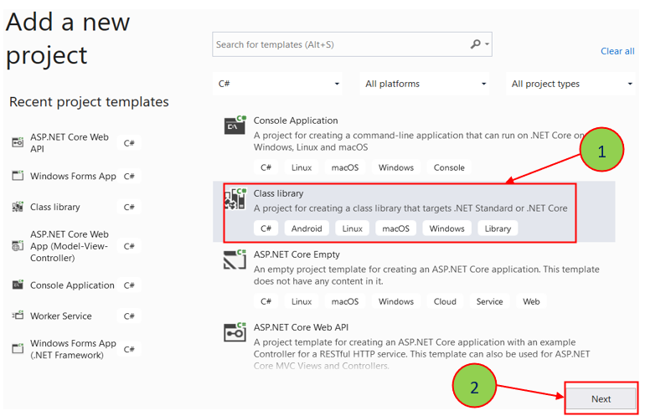

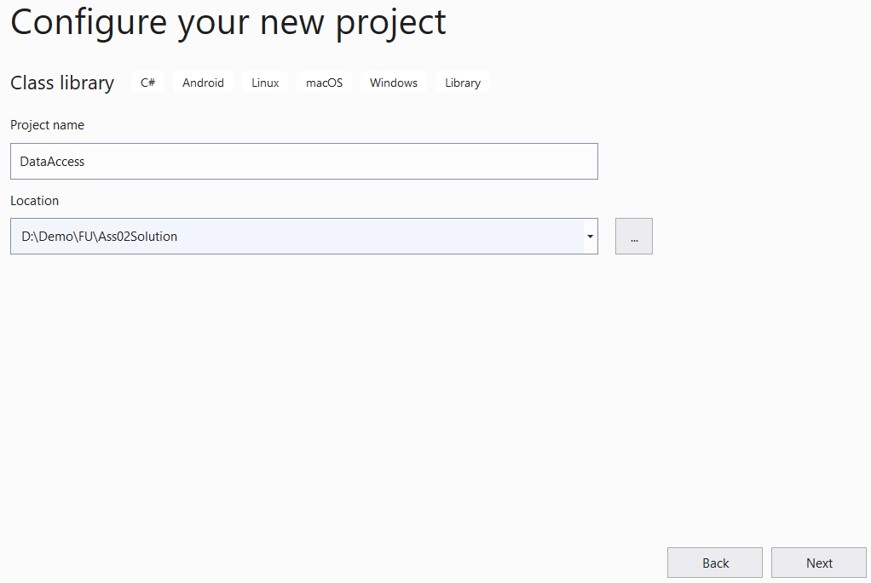

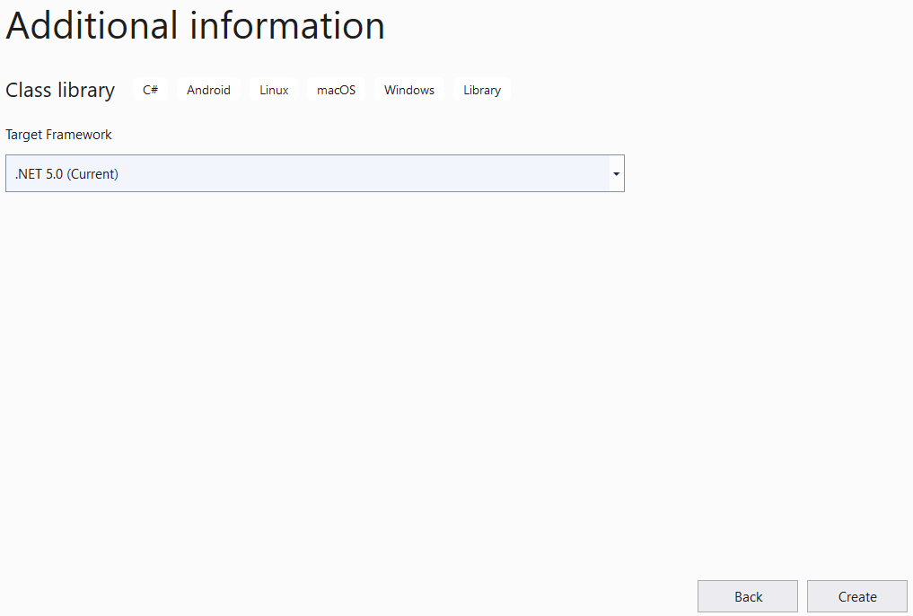

**Step 03.** Repeat **Step 02** to create a **BusinessObject** project.

**Step 04.** Create a Windows Forms project named **SalesWinApp**

* From the File menu | Add | New Project, on the Add New Project dialog, select “Windows Forms App” and performs steps as follows:

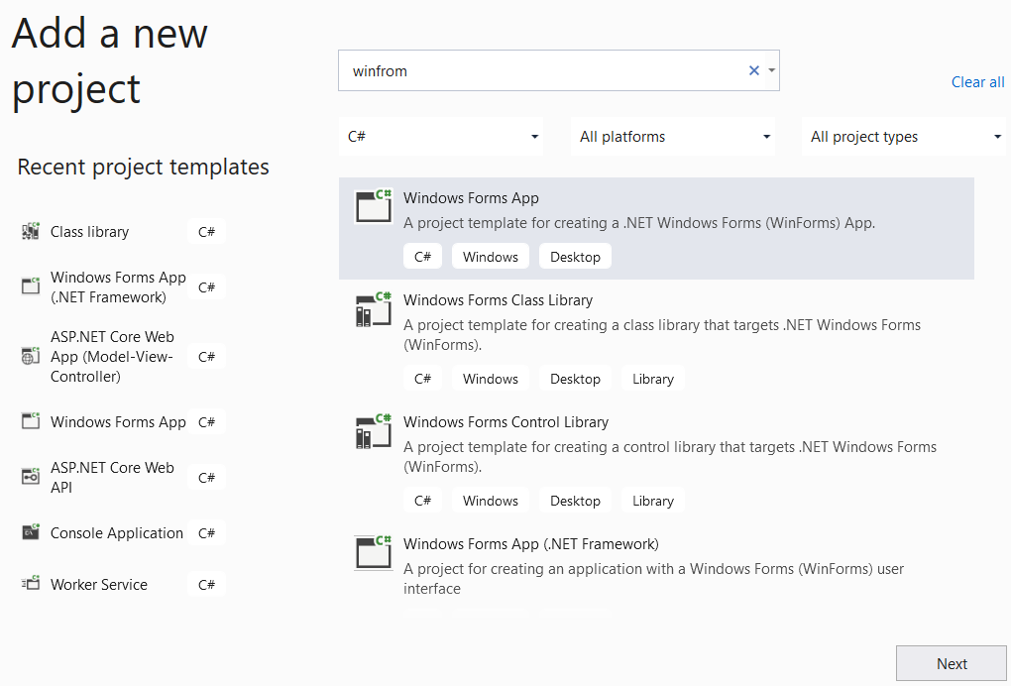

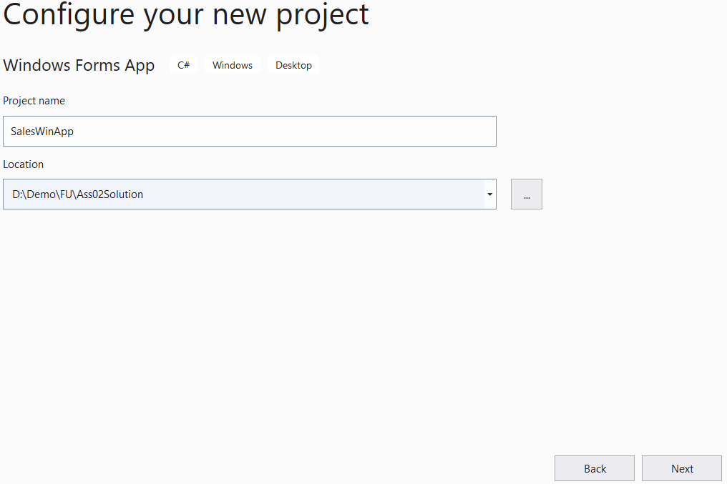

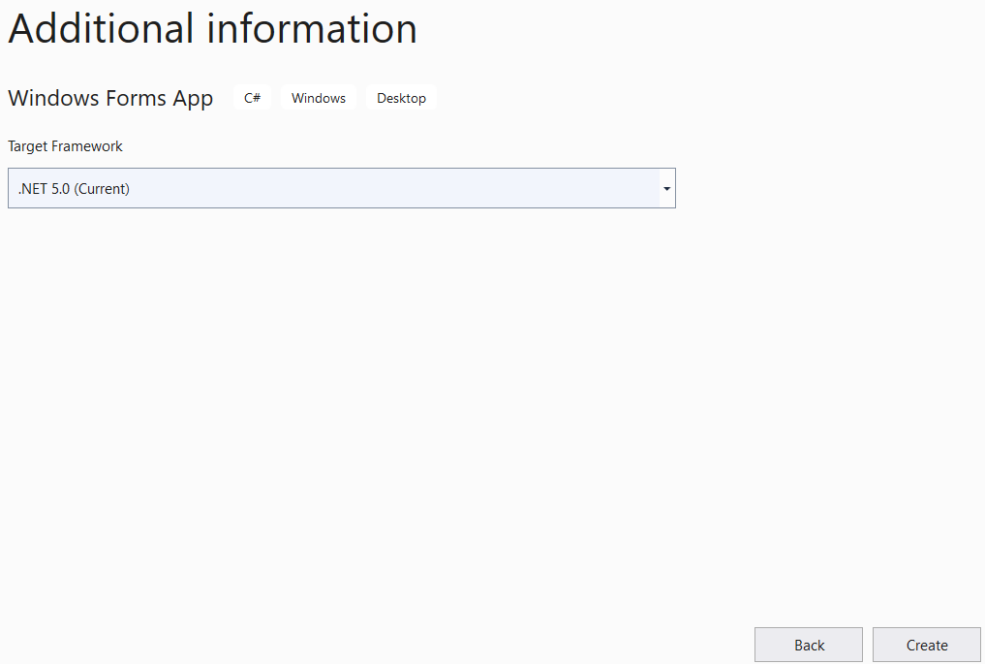

**Step 05**. Create folders and add class to the projects as follows:

# 

# Activity 02: Develop BusinessObject project [02 marks]

**Step 01**. Write codes to create classes and definition all data members

**Step 02**. Write codes to perform business rules for data members

# Activity 03: Develop DataAccess project [03 marks]

**Step 01**. Add a project reference to the **BusinessObject** project

**Step 02**. Write codes for **MemberDAO.cs, IMemberRepository.cs** and **MemberRepository.cs**

**Step 03**. Write codes for **ProductDAO.cs, IProductRepository.cs** and **ProductRepository.cs**

**Step 04**. Write codes for **OrderDAO.cs, IOrderRepository.cs** and **OrderRepository.cs**

**Step 05**. Write codes for **OrderDetailDAO.cs, IOrderDetailRepository.cs** and **OrderDetailRepository.cs**

***Hints*:** If using Entity Framework, you can install the AutoMapper package from Nuget to map Entity with Busines Object.

# Activity 04: Develop MyStoreWinApp project [03 marks]

**Step 01**. Add a reference to **BusinessObject** and **DataAccess** project

**Step 02**. Design UI forms and write codes to perform functions

***Hints***: Use MenuStrip, ToolStrip, StatusStrip on the MDI form (frmMain)

# Activity 05: Run the WinForms project and test all actions [01 mark]